16. feladat
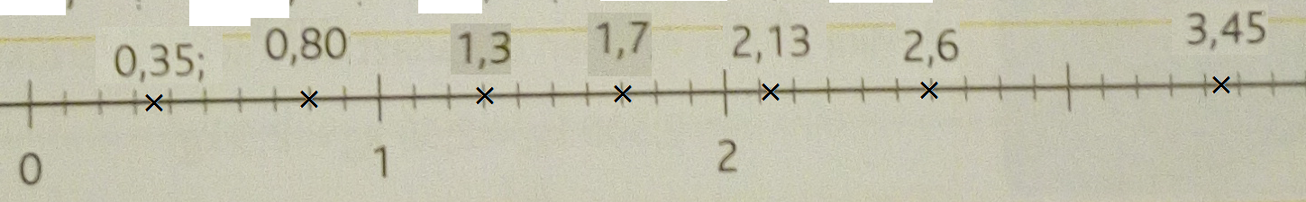

17./a
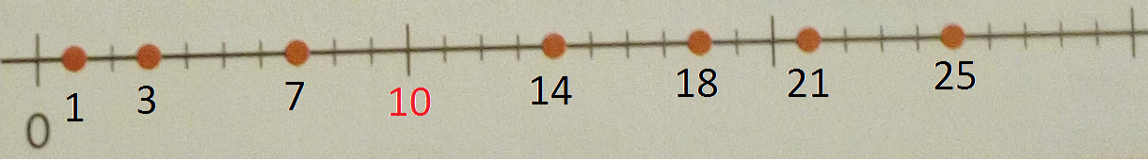
17/b
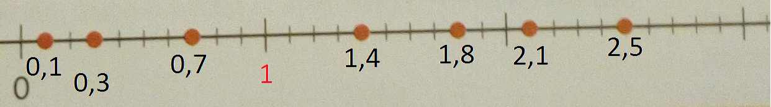
17/c
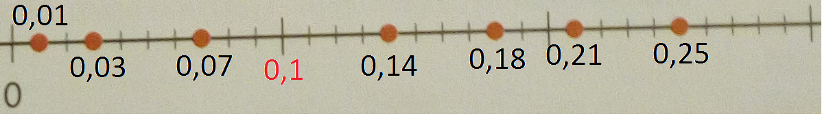
17/d
